

**Capstone Project Report**

**Report 3 – Software Requirement Specification**

– HoChiMinh, September 2020 –

**Table of Contents**

I. Project Report 3

1. Status Report 3

2. Team Involvements 3

3. Issues/Suggestions 3

II. Software Requirement Specification 4

1. Overall Description 4

1.1 Product Overview 4

1.2 Business Rules 4

2. User Requirements 5

2.1 Overview 5

2.2 List of use case 6

2.3 <<Feature name 2 – i.e: Meal Subscriptions>> 47

2.4 <<Next Feature Name..>> 47

3. Functional Requirements 48

3.1 System Functional Overview 48

3.2 <<Feature Name 1>> 50

3.3 <<Feature Name 2>> 50

4. Non-Functional Requirements 51

4.1 External Interfaces 51

4.2 Quality Attributes 52

5. Other Requirements 54

5.1 Appendix1 - Messages List 54

5.2 Appendix2 - … 54

5.3 … 54

# I. Project Report

## 1. Status Report

|  |  |  |  |
| --- | --- | --- | --- |
| **#** | **Work Item** | **Status** | **Notes (Work Item in Details)** |
| 1 |  | Pending |  |
| 2 |  | In Progress |  |
| 3 |  | Completed |  |

## 2. Team Involvements

|  |  |  |  |
| --- | --- | --- | --- |
| **#** | **Task** | **Member** | **Notes (Task Details, etc.)** |
| 1 |  | Thaott |  |
| 2 |  | Datbc |  |
| 3 |  | Kiendst |  |
| 4 |  | Mytn |  |

## 3. Issues/Suggestions

|  |  |  |  |
| --- | --- | --- | --- |
| **#** | **Issue** | **Status** | **Notes (Solution, Suggestion, etc.)** |
| 1 |  | Pending |  |
| 2 |  | In Progress |  |
| 3 |  | Completed |  |

# II. Software Requirement Specification

## 1. Overall Description

### 1.1 Product Overview

Hệ thống đặt thợ chụp ảnh là một hệ thống mới hô trợ khách hàng tìm kiếm nhanh chóng thợ chụp ảnh. Sơ đồ ngữ cảnh bên dưới mô tả các thực thể bên ngoài và giao diện của hệ thống phiên bản 1.0. Hệ thống sẽ dự kiến phát triển trong khu vực thành phố kết nối với các thợ chụp ảnh và studio.

*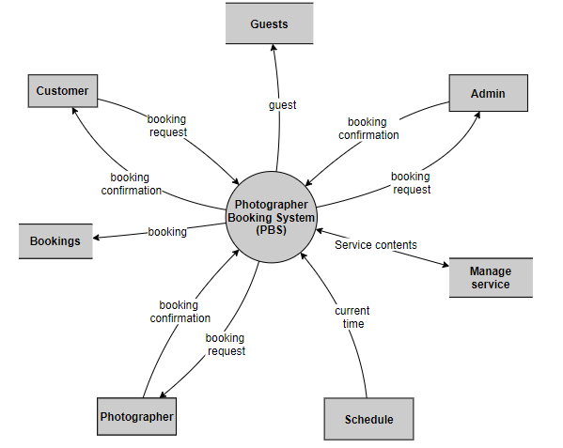Figure 1 - Context Diagram*

### 1.2 Business Rules

|  |  |
| --- | --- |
| ID | Rule Definition |
| BR-01 | Chỉ có thợ chụp ảnh được chỉnh sửa và thêm dịch vụ chụp hình. |
| BR-02 | Thợ chụp ảnh phải cập nhật trạng thái yêu cầu của khách hàng. |
| BR-03 | Khách hàng chỉ được đặt thợ trước trong vòng 3 tháng trở lại. |
| BR-04 | Lịch được hiển thị ở trang thông tin của thợ chụp ảnh khách hàng chỉ được xem. |
| BR-05 | Khách hàng đã đánh giá thì không có quyền xóa bình luận đó. |
| BR-06 | Sau khi đặt lịch khách hàng có quyền sửa đổi thông tin trước khi thợ chụp ảnh xác nhận. |
| BR-07 | Khách hàng chỉ được phép hủy yêu cầu trong khi trạng thái đang để “chờ xác nhận”. |

*Table 1 - Business rules*

## 2. User Requirements

### 2.1 Overview

#### a. Use Case Diagram

*Figure 2 - Use Case Diagram*

#### b. System Actors

|  |  |  |
| --- | --- | --- |
| **#** | **Actor** | **Description** |
| 1 | Administrator | Là người sẽ quản lý toàn hệ thống. |
| 2 | Photographer | Là người sẽ nhận được yêu cầu của khách hàng và sẽ nhận được đánh giá của khách hàng. Thợ chụp ảnh sẽ xác nhận yêu cầu được gửi đến, thông báo khi đến ngày chụp, ngày trả ảnh. Họ sẽ cũng cấp các dịch vụ , hình ảnh cho hệ thống. |
| 3 | Customer | Là người sẽ tìm kiếm thợ chụp ảnh và gửi yêu cầu đến cho thợ. Sẽ nhận được thông báo khi photographer xác nhận yêu cầu, đến ngày chụp, ngày trả ảnh.. Họ sẽ đánh giá chất lượng của thợ chụp ảnh sau khi hoàn thành yêu cầu. |
| 4 | Guest | Là người sẽ đăng kí tài khoản vào hệ thống và sẽ nhận được phản hồi từ hệ thống. |

*Table 2 - System Actors*

#### c. Use Cases List

|  |  |  |  |
| --- | --- | --- | --- |
| **ID** | **Use Case** | **Primary Actors** | **Secondary Actors** |
| 01 | Register | Guest |  |
| 02 | Login | Guest |  |
| 03 | Search photographer | Customer |  |
| 04 | Get photographer’s detail | Customer |  |
| 05 | Book Photographer | Customer |  |
| 06 | Review photographer | Customer |  |
| 07 | Get booking  (cancel, edit, accept, decline) | Customer, Photographer |  |
| 08 | Edit working calendar | Photographer |  |
| 09 | Get customer’s review | Photographer , Admin |  |
| 10 | Manage service  (Add , Edit, Remove) | Photographer |  |
| 11 | Manage album  (add , edit, remove) | Photographer |  |
| 12 | Manage user  (get user’s activity, unlock user, lock user) | Admin |  |
| 13 | Manage shooting category  (add, edit, remove) | Admin |  |
| 14 | Get profile  (edit profile) | Authenticated User |  |
| 15 | Logout | Authenticated User |  |
| 16 | Change password | Authenticated User |  |

*Table 3 - Use Case List*

### 2.2 List of use case

#### a. <Guest > Overview use case

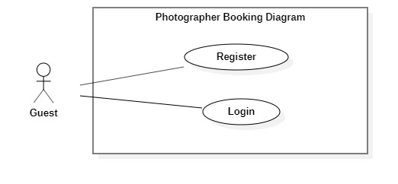

*Figure 3 - <Guest> Over View Use Case*

1. *<Guest> Register*

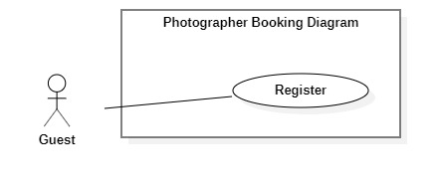

*Figure 4 - <Guest> Register*

|  |  |  |  |
| --- | --- | --- | --- |
| UC ID and Name: | **PBS-UC-01 Register** | | |
| Created By: | Mytn | Date Created: | 08/10/2020 |
| Primary Actor: | Guest | Secondary Actors: |  |
| Trigger: | The Guest taps “Đăng ký” on “Đăng nhập” screen | | |
| Description: | Before using the system, the guest must have an account. | | |
| Preconditions: | - Guest launches the mobile application.  - Guest is at the “Đăng nhập” screen.  - Guest has connected to the Internet. | | |
| Post-conditions: | Success: The guest registers an account successfully.  Fail: System shows error messages. | | |
| Normal Flow: | |  |  |  | | --- | --- | --- | | **Step** | **Actor Action** | **System Response** | | 1 | The Guest taps “Đăng kí” on “Đăng nhập” screen. | The system shows “Thông tin đăng kí” screen with the following inputs.  -“Họ và tên”: text input, required.  - “ Tên đăng nhập”: text input, required  - “Mật khẩu” : password input , required.  -“Xác nhận mật khẩu”: password input , required.  -“Số điện thoại”: phone number input.  - “Email”: text input, required. | | 2 | The guest taps the “Đăng kí” button. | - The system validates inputted data [Exception 1,2,3,4,5,6,7]..  - The system shows the “Đăng nhập” screen. | | | |
| Alternative Flows: | N/A | | |
| Exceptions: | |  |  |  | | --- | --- | --- | | **No** | **Actor Action** | **System Response** | | 1 | Network problem | System shows an error message: “Vui lòng kiếm tra lại mạng Internet”. | | 2 | - “Họ và tên” is empty  - “Tên đăng nhập” is empty  - “Mật khẩu” is empty  - “Xác nhận mật khẩu” is empty.  - “Số điện thoại” is empty  - “Email” is empty | System shows an error message: “Thông tin này là bắt buộc” | | 3 | Password and Confirm password is not matched. | System shows an error message: “Mật khẩu nhập lại không khớp”. | | 4 | Register successfully | System shows an error message: “Đăng kí thành công”. | | 5 | “Email” Is invalid | System shows an error message:  “Email mail này không hợp lệ. Vui lòng nhập email khác.” | | 6 | - “Tên đăng nhập” not enough character.  - “Mật khẩu” not enough character. | System shows an error message:  “Bạn vui lòng nhập đủ 8 – 16 kí tự.” | | 7 | “Tên đăng nhập” is exist. | System shows an error message:  “Tên đăng nhập của bạn đã có người sửa dụng. Vui lòng nhập tên khác.” | | | |
| Priority: | Medium | | |
| Frequency of Use: | N/A | | |
| Business Rules: | N/A | | |
| Other Information: | N/A | | |
| Assumptions: | N/A | | |

*Table 4 - <Guest> Register use case specification*

1. 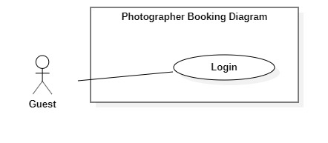***<Guest> Login***

*Figure 5 - <Guest> Login*

|  |  |  |  |
| --- | --- | --- | --- |
| UC ID and Name: | **PBS-UC-02 Login** | | |
| Created By: | Mytn | Date Created: | 08/10/2020 |
| Primary Actor: | Guest | Secondary Actors: |  |
| Trigger: | The Guest taps “Đăng nhập” on “Đăng nhập” screen | | |
| Description: | Before using the system, the guest must login. | | |
| Preconditions: | - Guest launches the mobile application.  - Guest is at the “Đăng nhập” screen.  - Guest has connected to the Internet. | | |
| Post-conditions: | Success: The guest login to the system successfully.  Fail: System shows error messages. | | |
| Normal Flow: | |  |  |  | | --- | --- | --- | | **Step** | **Actor Action** | **System Response** | | 1 | The Guest opened mobile app. | “Đăng nhập” screen is show with the following inputs:  - “ Tên đăng nhập”: text input, required  - “Mật khẩu” : password input , required.  - “Đăng nhập” : button | | 2 | The guest inputs name and password and taps “Đăng nhập” button. | - The system validates inputted data [Exception 1,2,3]  - The system shows the main screen. | | | |
| Alternative Flows: | N/A | | |
| Exceptions: | |  |  |  | | --- | --- | --- | | **No** | **Actor Action** | **System Response** | | 1 | Network problem | System shows an error message : “Vui lòng kiếm tra lại mạng Internet”. | | 2 | - “Tên đăng nhập” is empty  - “Mật khẩu” is empty | System shows an error message : “Thông tin này là bắt buộc” | | 3 | Name and Password is incorrect. | System shows an error message : “Thông tin đăng nhập không chính xác”. | | | |
| Priority: | Medium | | |
| Frequency of Use: | N/A | | |
| Business Rules: | N/A | | |
| Other Information: | N/A | | |
| Assumptions: | N/A | | |

*Table 5 - <Guest> Login use case specification*

#### b. <Customer> Overview use case

*Figure 6 - <Customer> Overview use case*

1. 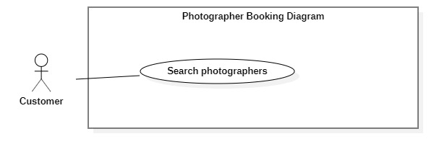***<Customer> Search Photographer***

*Figure 7 - <Customer> Search Photographer*

|  |  |  |  |
| --- | --- | --- | --- |
| UC ID and Name: | **PBS-UC-03 Search photographer** | | |
| Created By: | Mytn | Date Created: | 08/10/2020 |
| Primary Actor: | Customer | Secondary Actors: |  |
| Trigger: | The customer sends request to find photographers | | |
| Description: | The customer need to find the photographer and service name. -> The customer need to find photographers. | | |
| Preconditions: | - The customer has been authenticated.  - The customer has accessed to the Internet. | | |
| Post-conditions: | Success: A list of photographers is shown.  Fail: System shows error messages. | | |
| Normal Flow: | |  |  |  | | --- | --- | --- | | **Step** | **Actor Action** | **System Response** | | 1 | The customer input name photographer or service name after click search icon button. | - The system validates inputted data [Exception1]  - The system shows a list photographer or service name. | | | |
| Alternative Flows: | N/A | | |
| Exceptions: | |  |  |  | | --- | --- | --- | | **No** | **Actor Action** | **System Response** | | 1 | Network problem | System shows an error message : “Vui lòng kiếm tra lại mạng Internet”. | | | |
| Priority: | High | | |
| Frequency of Use: | N/A | | |
| Business Rules: | N/A | | |
| Other Information: | The customer can view a list of available photographers and category of main screen. | | |
| Assumptions: | N/A | | |

*Table 6 - <Customer> Search photographer use case specification*

1. ***<Customer> Get photographer’s detail***

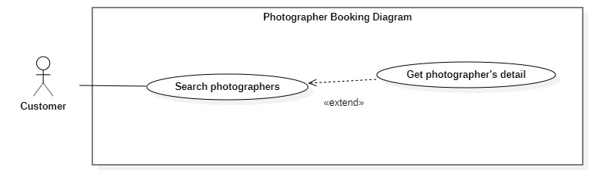

*Figure 8 - <Customer> Get photographer's Detail*

|  |  |  |  |
| --- | --- | --- | --- |
| UC ID and Name: | **PBS-UC-04 Get photographer’s detail** | | |
| Created By: | Mytn | Date Created: | 08/10/2020 |
| Primary Actor: | Customer | Secondary Actors: |  |
| Trigger: | The customer taps photographer or photographer icon. | | |
| Description: | The customer need to view profile of photographer. | | |
| Preconditions: | - The customer has been authenticated.  - The customer has opened location service.  - The customer has accessed to the Internet.  - The customer is at “Danh sách photographer” screen. | | |
| Post-conditions: | Success: The system shown the photographer’s page.  Fail: System shows error messages. | | |
| Normal Flow: | |  |  |  | | --- | --- | --- | | **Step** | **Actor Action** | **System Response** | | 1 | The customer taps on the photographer on the result a list photographer search or photographer view main screen. | The system shows the photographer profile screen with the following information: [Exception 1]  - “Mô tả”: introduction or a brief description.  - “Đã đặt” number of people and number of star: number of booking.  - “Album”: album photo of photographer.  - “Bình luận”: list of feebacks.  - “Thời gian biểu”: schedule of photographer.  - “Gói các dịch vụ”: list of service of photographer.  - “tiếp tục”: button | | | |
| Alternative Flows: | N/A | | |
| Exceptions: | |  |  |  | | --- | --- | --- | | **No** | **Actor Action** | **System Response** | | 1 | Network problem | System shows an error message : “Vui lòng kiếm tra lại mạng Internet”. | | | |
| Priority: | Medium | | |
| Frequency of Use: | N/A | | |
| Business Rules: | N/A | | |
| Other Information: | N/A | | |
| Assumptions: | N/A | | |

*Table 7 - <Customer> Get photographer's detail use case specification*

1. ***<Customer> Book photographer***

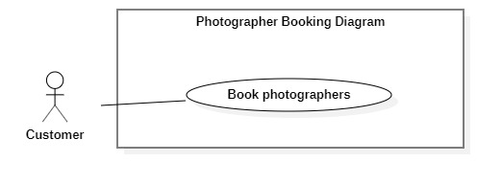

*Figure 9 - <Customer> Book photographer*

|  |  |  |  |
| --- | --- | --- | --- |
| UC ID and Name: | **PBS-UC-05 Book photographer** | | |
| Created By: | Mytn | Date Created: | 08/10/2020 |
| Primary Actor: | Customer | Secondary Actors: |  |
| Trigger: | The customer taps the “Tiếp tuc” button. | | |
| Description: | The customer can book photographer . | | |
| Preconditions: | - The customer has been authenticated.  - The customer has selected a photographer and view their profile photographer.  - The customer has accessed to the Internet. | | |
| Post-conditions: | Success: The customer book photographer successfully.  Fail: System shows error messages. | | |
| Normal Flow: | |  |  |  | | --- | --- | --- | | **Step** | **Actor Action** | **System Response** | | 1 | The customer taps “Tiếp tục” button after click choose “Gói dịch vụ”. | The system shows “Tạo yêu cầu” screen. The customer input following:  - “Photographer”: default  - “Thời gian bắt đầu”: The customer can choose date and start time.  - “Thời gian trả ảnh”: choose date and end time.  - “Địa điểm”: input text, required.  - “Gói dịch vụ”: the customer can change.  - “Tổng cộng”: price  - “Tạo yêu cầu”: button | | 2 | The customer taps “Tạo yêu cầu” button | - The system validates inputted data [Exception1]  - The system creates a new request and notifies the chosen photographer.[Exception 2] | | | |
| Alternative Flows: | N/A | | |
| Exceptions: | |  |  |  | | --- | --- | --- | | **No** | **Actor Action** | **System Response** | | 1 | Network problem | System shows an error message : “Vui lòng kiếm tra lại mạng Internet”. | | 2 | The customer book photographer successfully. | System shows an error message : “Gửi yêu cầu thành công” | | 3 | The customer do not choose “Thời gian” and “Địa điểm”. | System shows an error message : “Bạn chưa chọn thông tin” | | | |
| Priority: | High | | |
| Frequency of Use: | N/A | | |
| Business Rules: | N/A | | |
| Other Information: | N/A | | |
| Assumptions: | N/A | | |

*Table 8 - <Customer> Book photographer use case specification*

1. ***<Customer> Review photographers***

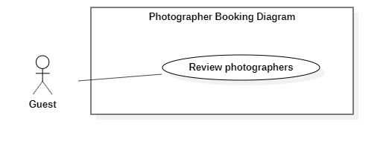

*Figure 10 - <Customer> Review photographers*

|  |  |  |  |
| --- | --- | --- | --- |
| UC ID and Name: | **PBS-UC-06 Review photographers** | | |
| Created By: | Mytn | Date Created: | 08/10/2020 |
| Primary Actor: | Customer | Secondary Actors: |  |
| Trigger: | The customer taps “Đánh giá” to the request successfully history. | | |
| Description: | The customer need to write comment and rating to the photographer service. | | |
| Preconditions: | - The customer has been authenticated.  - The customer book photographer successfully.  - The customer has accessed to the Internet. | | |
| Post-conditions: | Success: The system shows comment and rating of the customer in photographer page.  Fail: System shows error messages. | | |
| Normal Flow: | |  |  |  | | --- | --- | --- | | **Step** | **Actor Action** | **System Response** | | 1 |  | After the request’s status is updated to “Đã hoàn thành”, “Đánh giá” button and “Bỏ qua” button is shown. | | 2 | The customer taps “Đánh giá” button | The system will go to “Bình luận” of photographer page. The customer input with the following:  - star icon: The customer choose star  -“Bình luận”: Text input, optional | | 3 | The customer taps “Gửi” button | - The system validates inputted data [Exception1,2,3]  - The system shows comment and rating of customer. | | | |
| Alternative Flows: | N/A | | |
| Exceptions: | |  |  |  | | --- | --- | --- | | **No** | **Actor Action** | **System Response** | | 1 | Network problem | System shows an error message: “Vui lòng kiếm tra lại mạng Internet”. | | 2 | Enter many character. | System shows an error message:  “Bạn chỉ được nhập tối đa 150 ký tự” | | 3 | Enter less character. | System shows an error message:  “Bạn phải nhập tối thiểu 50 ký tự”. | | | |
| Priority: | High | | |
| Frequency of Use: | N/A | | |
| Business Rules: | BR-05 | | |
| Other Information: | N/A | | |
| Assumptions: | N/A | | |

*Table 9 - <Customer> Review photographers use case specification*

1. ***<Customer> Get booking***

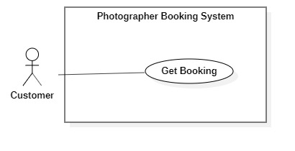

Figure - <Customer> Get booking

|  |  |  |  |
| --- | --- | --- | --- |
| UC ID and Name: | **PBS-UC-07 Get booking** | | |
| Created By: | Mytn | Date Created: | 08/10/2020 |
| Primary Actor: | Customer | Secondary Actors: | Photographer |
| Trigger: | The customer navigates to “Lịch sử” screen. | | |
| Description: | The customer can view request “Lịch sử” | | |
| Preconditions: | - The customer has been authenticated.  - The customer has accessed to the Internet.  - The customer book photographer. | | |
| Post-conditions: | Success: The customer can view request history.  Fail: System shows error messages. | | |
| Normal Flow: | |  |  |  | | --- | --- | --- | | **Step** | **Actor Action** | **System Response** | | 1 | The customer navigates to “Lịch sử” screen. | The system shows list of request of customer has made. [Exception 1] | | | |
| Alternative Flows: | N/A | | |
| Exceptions: | |  |  |  | | --- | --- | --- | | **No** | **Actor Action** | **System Response** | | 1 | Network problem | System shows an error message : “Vui lòng kiếm tra lại mạng Internet”. | | | |
| Priority: | Low | | |
| Frequency of Use: | N/A | | |
| Business Rules: | N/A | | |
| Other Information: | N/A | | |
| Assumptions: | N/A | | |

*Table 10 - <Customer> Get booking use case specification*

1. ***<Customer> Edit Booking***

*Figure 12 - <Customer> Edit booking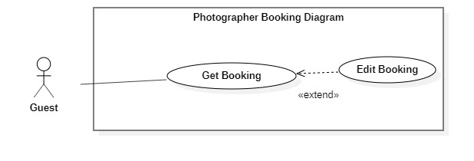*

|  |  |  |  |
| --- | --- | --- | --- |
| UC ID and Name: | **PBS-UC-08 Edit booking** | | |
| Created By: | Mytn | Date Created: | 08/10/2020 |
| Primary Actor: | Customer | Secondary Actors: |  |
| Trigger: | The customer taps on “Thay đổi” button in the request “Đang chờ xác nhận”. | | |
| Description: | The customer need change information of request. | | |
| Preconditions: | - The customer has been authenticated.  - The customer has accessed to the Internet.  - The status of request is “Đang chờ xác nhận”. | | |
| Post-conditions: | Success: A list photographer is shown.  Fail: System shows error messages. | | |
| Normal Flow: | |  |  |  | | --- | --- | --- | | **Step** | **Actor Action** | **System Response** | | 1 | The customer taps “Đang chờ xác nhận” or “Sắp diễn ra” request. | The system shows detail of request.  - “Photographer”: text  - “Ngày chụp”: text  - “Ngày trả ảnh”: text  - “Địa điểm”: text  - “Gói dịch vụ”: text  - “Tổng cộng”: text  - “Hủy”: button  - “Thay đổi”: button on the “Ngày chụp”, “Ngày trả ảnh”, “Địa điểm”, “Gói dịch vụ” | | 2 | The customer taps “Thay đổi” button on the item. | The system shows “Chi tiết yêu cầu” page. The customer input following:  - “Photographer”: text, default  - “Ngày chụp”: date and time  - “Ngày trả ảnh”: date and time  - “Địa điểm”: input text  - “Gói dịch vụ”: optional  - “Tổng cộng”: default following the “Gói dịch vụ”.  - “Hủy”: button  - “xác nhận”: button | | 3 | The customer taps “Xác nhận” button. | - The system validates inputted data [Exception 1, 2]  - The system creates a new request and notifies the chosen photographer.[Exception 2] | | | |
| Alternative Flows: | N/A | | |
| Exceptions: | |  |  |  | | --- | --- | --- | | **No** | **Actor Action** | **System Response** | | 1 | Network problem | System shows an error message : “Vui lòng kiếm tra lại mạng Internet”. | | 2 | The customer book photographer successfully. | System shows an error message : “Gửi yêu cầu thành công” | | 3 | The customer do not choose “Thời gian” and “Địa điểm”. | System shows an error message : “Bạn chưa chọn thông tin” | | | |
| Priority: | Medium | | |
| Frequency of Use: | N/A | | |
| Business Rules: | N/A | | |
| Other Information: | N/A | | |
| Assumptions: | N/A | | |

*Table 11- <Customer> Edit booking use case specification*

1. 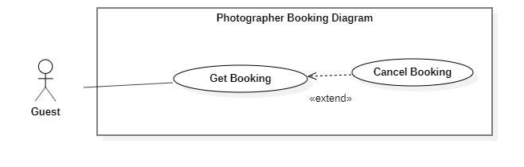***<Customer> Cancel booking***

*Figure 13 - <Customer> Cancel booking*

|  |  |  |  |
| --- | --- | --- | --- |
| UC ID and Name: | **PBS-UC-09 Cancel booking** | | |
| Created By: | Mytn | Date Created: | 08/10/2020 |
| Primary Actor: | Customer | Secondary Actors: |  |
| Trigger: | The customer taps “Hủy” button on the booking detail. | | |
| Description: | The customer need cancel booking . | | |
| Preconditions: | - The customer has been authenticated.  - The customer has accessed to the Internet.  - The status of request is “Đang chờ xác nhận”. | | |
| Post-conditions: | Success: the customer cancel booking successfully.  Fail: System shows error messages. | | |
| Normal Flow: | |  |  |  | | --- | --- | --- | | **Step** | **Actor Action** | **System Response** | | 1 | The customer taps “Đang chờ xác nhận” request. | The system shows detail of request.  - “Photographer”: text  - “Ngày chụp”: text  - “Ngày trả ảnh” : text  - “Địa điểm”: text  - “Gói dịch vụ”: text  - “Tổng cộng”: text  - “Hủy”: button | | 2 | The customer taps “Hủy” button. | The system shows notifies the chosen customer: [Exception 2]  - “Có”: button  - “Không”: button | | 3 | The customer taps “Có” button. | - The system update request the chosen photographer [Exception 1] | | | |
| Alternative Flows: | N/A | | |
| Exceptions: | |  |  |  | | --- | --- | --- | | **No** | **Actor Action** | **System Response** | | 1 | Network problem | System shows an error message : “Vui lòng kiếm tra lại mạng Internet”. | | 2 | The customer taps “Hủy” button. | System shows an error message : “Bạn có muốn hủy lần đặt photographer này không?” | | | |
| Priority: | Medium | | |
| Frequency of Use: | N/A | | |
| Business Rules: | N/A | | |
| Other Information: | N/A | | |
| Assumptions: | N/A | | |

*Table 12 - <Customer>Cancel booking use case specification*

#### c. <Photographer> Overview Use Case

*Figure 14 - <Photographer> Overview use case*

1. ***<Photographer> Get Booking***



*Figure 15 - <Photographer> Get booking*

|  |  |  |  |
| --- | --- | --- | --- |
| UC ID and Name: | **PBS-UC-10 Get booking** | | |
| Created By: | Mytn | Date Created: | 08/10/2020 |
| Primary Actor: | Photographer | Secondary Actors: |  |
| Trigger: | Photographers taps “Trang Chủ” icon in Photographer’s application | | |
| Description: | The photographer can view list of their bookings including all status. | | |
| Preconditions: | - The photographer has been authenticated.  - The photographer has accessed to the Internet. | | |
| Post-conditions: | Success: the system shows lists of request.  Fail: System shows error messages. | | |
| Normal Flow: | |  |  |  | | --- | --- | --- | | **Step** | **Actor Action** | **System Response** | | 1 |  | The system shows all request of customer to the main screen of photographer. | | | |
| Alternative Flows: | N/A | | |
| Exceptions: | |  |  |  | | --- | --- | --- | | **No** | **Actor Action** | **System Response** | | 1 | Network problem | System shows an error message : “Vui lòng kiếm tra lại mạng Internet”. | | | |
| Priority: | Medium | | |
| Frequency of Use: | N/A | | |
| Business Rules: | N/A | | |
| Other Information: | N/A | | |
| Assumptions: | N/A | | |

*Table 13 - <Photographer>Get booking use case specification*

1. ***<Photographer> Accept Booking***

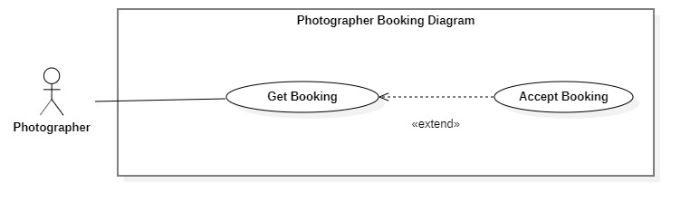

*Figure 16 - <Photographer> Accept Booking*

|  |  |  |  |
| --- | --- | --- | --- |
| UC ID and Name: | **PBS-UC-11 Accept booking** | | |
| Created By: | Mytn | Date Created: | 08/10/2020 |
| Primary Actor: | Photographer | Secondary Actors: | Customer |
| Trigger: | The photographer taps “Xác nhận” button. | | |
| Description: | The photographer can create a new request. | | |
| Preconditions: | - The photographer has been authenticated.  - The photographer has accessed to the Internet.  - The status of request is “Đang chờ xác nhận”. | | |
| Post-conditions: | Success: the system change status of request is “Sắp tiến hành”.  Fail: System shows error messages. | | |
| Normal Flow: | |  |  |  | | --- | --- | --- | | **Step** | **Actor Action** | **System Response** | | 1 | The photographer taps “Xác nhận” button | - The system will change status of request is “Sắp tiến hành”. [Exception 1]  - The system send notifies to the customer. [Exception 2] | | | |
| Alternative Flows: | N/A | | |
| Exceptions: | |  |  |  | | --- | --- | --- | | **No** | **Actor Action** | **System Response** | | 1 | Network problem | System shows an error message : “Vui lòng kiếm tra lại mạng Internet”. | | 2 | The system send notifies to the customer. | System shows an error message : “Yêu cầu của bạn đã được xác nhận” | | | |
| Priority: | Medium | | |
| Frequency of Use: | N/A | | |
| Business Rules: | The customer can’t edit or remove request if the photographer has accepted booking. | | |
| Other Information: | N/A | | |
| Assumptions: | The system allows the photographer can accept booking. | | |

*Table 14 - <Photographer> Accept Booking use case specification*

1. 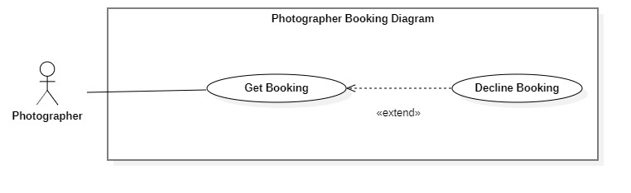***<Photographer> Decline Booking***

*Figure 17 - <Photographer> Decline Booking*

|  |  |  |  |
| --- | --- | --- | --- |
| UC ID and Name: | **PBS-UC-12 Decline booking** | | |
| Created By: | Mytn | Date Created: | 08/10/2020 |
| Primary Actor: | Photographer | Secondary Actors: | Customer |
| Trigger: | The photographer taps “Hủy” button. | | |
| Description: | The photographer can decline booking. | | |
| Preconditions: | - The photographer has been authenticated.  - The photographer has accessed to the Internet.  - The status of request is “Đang chờ xác nhận”. | | |
| Post-conditions: | Success: the system send notifies to the customer.  Fail: System shows error messages. | | |
| Normal Flow: | |  |  |  | | --- | --- | --- | | **Step** | **Actor Action** | **System Response** | | 1 | The photographer taps “Hủy” button | - The system send notification to the customer. [Exception 1, 2] | | | |
| Alternative Flows: | N/A | | |
| Exceptions: | |  |  |  | | --- | --- | --- | | **No** | **Actor Action** | **System Response** | | 1 | Network problem | System shows an error message : “Vui lòng kiếm tra lại mạng Internet”. | | 2 | The system send notification to the customer. | System shows an error message : “Yêu cầu của bạn đã bị từ chối” | | | |
| Priority: | Medium | | |
| Frequency of Use: | N/A | | |
| Business Rules: | N/A | | |
| Other Information: | N/A | | |
| Assumptions: | N/A | | |

*Table 15 - <Photographer> Cancel Booking Use Case Specification*

1. 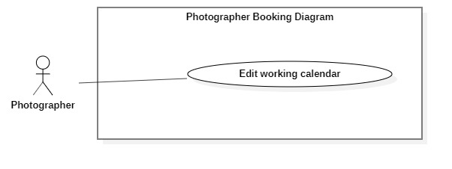***<Photographer> Edit working calendar***

*Figure 18 - <Photographer> Edit working calendar*

|  |  |  |  |
| --- | --- | --- | --- |
| UC ID and Name: | **PBS-UC-13 Edit working calendar** | | |
| Created By: | Mytn | Date Created: | 08/10/2020 |
| Primary Actor: | Photographer | Secondary Actors: | Customer |
| Trigger: | The photographer taps date in calendar. | | |
| Description: | The photographer can edit working calendar. | | |
| Preconditions: | - The photographer has been authenticated.  - The photographer has accessed to the Internet. | | |
| Post-conditions: | Success: the system update calendar of photographer.  Fail: System shows error messages. | | |
| Normal Flow: | |  |  |  | | --- | --- | --- | | **Step** | **Actor Action** | **System Response** | | 1 | The photographer taps day. | The system shows detail of day. Photographer can view: [Exception 1].  - A list request of customer following start time | | 2 | The photographer taps day in the future and empty request. |  | | | |
| Alternative Flows: | N/A | | |
| Exceptions: | |  |  |  | | --- | --- | --- | | **No** | **Actor Action** | **System Response** | | 1 | Network problem | System shows an error message : “Vui lòng kiếm tra lại mạng Internet”. | | 2 | The system send notification to the customer. | System shows an error message : “Yêu cầu của bạn đã bị từ chối” | | | |
| Priority: | Medium | | |
| Frequency of Use: | N/A | | |
| Business Rules: | N/A | | |
| Other Information: | N/A | | |
| Assumptions: | The system allows the photographer edit working calendar successfully. | | |

Table - <Photographer>Edit Working Calendar Use Case Specification

1. ***<Photographer> Get customer’s review***

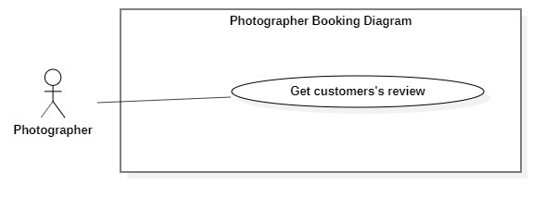

*Figure 19 - <Photographer> Get customer's review*

|  |  |  |  |
| --- | --- | --- | --- |
| UC ID and Name: | **PBS-UC-14 Get customer’s review** | | |
| Created By: | Mytn | Date Created: | 08/10/2020 |
| Primary Actor: | Photographer | Secondary Actors: | Admin |
| Trigger: | The photographer taps “Trang cá nhân” page. | | |
| Description: | The photographer can view customer’s review. | | |
| Preconditions: | - The photographer has been authenticated.  - The photographer has accessed to the Internet. | | |
| Post-conditions: | Success: the system send notifies to the customer.  Fail: System shows error messages. | | |
| Normal Flow: | |  |  |  | | --- | --- | --- | | **Step** | **Actor Action** | **System Response** | | 1 | The photographer taps “Trang cá nhân” page. | - The system shows “Trang cá nhân” page of the photographer. [Exception 1] | | | |
| Alternative Flows: | N/A | | |
| Exceptions: | |  |  |  | | --- | --- | --- | | **No** | **Actor Action** | **System Response** | | 1 | Network problem | System shows an error message : “Vui lòng kiếm tra lại mạng Internet”. | | | |
| Priority: | Medium | | |
| Frequency of Use: | N/A | | |
| Business Rules: | - The photographer can’t edit or remove comment of the customer.  -The photographer can’t write comment or rating. | | |
| Other Information: | N/A | | |
| Assumptions: | The system allows the photographer can view review. | | |

*Table 17 - <Photographer> Get Customer’s Review Use Case Specification*

1. 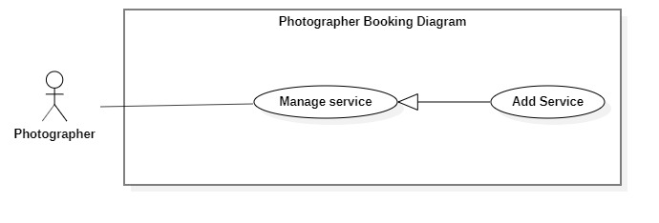***<Photographer> Add service***

*Figure 20 - <Photographer> Add service*

|  |  |  |  |
| --- | --- | --- | --- |
| UC ID and Name: | **PBS-UC-15 Add Service** | | |
| Created By: | Mytn | Date Created: | 08/10/2020 |
| Primary Actor: | Photographer | Secondary Actors: | Customer |
| Trigger: | The photographer taps add icon on “Trang cá nhân” screen. | | |
| Description: | The photographer can add service. | | |
| Preconditions: | - The photographer has been authenticated.  - The photographer has accessed to the Internet. | | |
| Post-conditions: | Success: the photographer add service successfully.  Fail: System shows error messages. | | |
| Normal Flow: | |  |  |  | | --- | --- | --- | | **Step** | **Actor Action** | **System Response** | | 1 | The photographer taps “Trang cá nhân” screen and taps add icon. | The system shows list of services the photographer has added with the following information:  - “Tên gói”: input text, required.  - “Nội dung”: input text, required  - “Giá”: input text, required  - “Thêm dịch vụ”: button | | 2 | The photographer taps “Thêm dịch vụ” button | - The system validates inputted data [Exception 1,2].  - The system sends notifies to the customer. [Exception 3]. | | | |
| Alternative Flows: | N/A | | |
| Exceptions: | |  |  |  | | --- | --- | --- | | **No** | **Actor Action** | **System Response** | | 1 | Network problem | System shows an error message : “Vui lòng kiếm tra lại mạng Internet”. | | 2 | “Tên gói” and “giá” is empty | System shows an error message : “Thông tin này bắt buộc” | | 3 | Add service successfully | System shows an error message:  “Thêm dịch vụ thành công”. | | | |
| Priority: | High | | |
| Frequency of Use: | N/A | | |
| Business Rules: | Only the photographer can add service. | | |
| Other Information: | N/A | | |
| Assumptions: | The system allows the photographer can add service successfully. | | |

*Table 18 - <Photographer> Add Service Use case Specification*

1. 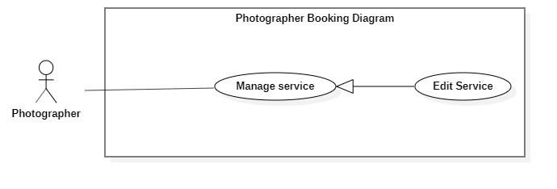***<Photographer> Edit service***

*Figure 21 - <Photographer> Edit Service*

|  |  |  |  |
| --- | --- | --- | --- |
| UC ID and Name: | **PBS-UC-16 Edit service** | | |
| Created By: | Mytn | Date Created: | 08/10/2020 |
| Primary Actor: | Photographer | Secondary Actors: | Customer |
| Trigger: | The photographer taps “Thay đổi” button on “Gói dịch vụ” detail page. | | |
| Description: | The photographer can edit service. | | |
| Preconditions: | - The photographer has been authenticated.  - The photographer has accessed to the Internet.  - The service pack available. | | |
| Post-conditions: | Success: the photographer edit service successfully.  Fail: System shows error messages. | | |
| Normal Flow: | |  |  |  | | --- | --- | --- | | **Step** | **Actor Action** | **System Response** | | 1 | The photographer taps “Gói dịch vụ” . | The system shows list of services the photographer has view information:  - “Tên gói”: text, required.  - “Nội dung”: text, required  - “Giá”: text, required  - “Thêm dịch vụ”: button  - “Thay đổi”: button | | 2 | The photographer taps “Thay đổi” button | The system shows list of services the photographer has inputs with the following information:  - “Tên gói”: input text, required.  - “Nội dung”: input text, required  - “Giá”: input text, required  - “Xác nhận”: button | | 3 | The photographer taps “Xác nhận” button | - The system validates inputted data [Exception 1,2].  - The system sends nontifies to the customer. [Exception 3]. | | | |
| Alternative Flows: | N/A | | |
| Exceptions: | |  |  |  | | --- | --- | --- | | **No** | **Actor Action** | **System Response** | | 1 | Network problem | System shows an error message : “Vui lòng kiếm tra lại mạng Internet”. | | 2 | “Tên gói” and “giá” is empty | System shows an error message : “Thông tin này bắt buộc” | | 3 | Edit service successfully | System shows an error message:  “Thay đổi thành công”. | | | |
| Priority: | High | | |
| Frequency of Use: | N/A | | |
| Business Rules: | Only the photographer can edit service. | | |
| Other Information: | N/A | | |
| Assumptions: | The system allows the photographer can edit service successfully. | | |

*Table 19 - <Photographer>Edit service use case specification*

1. 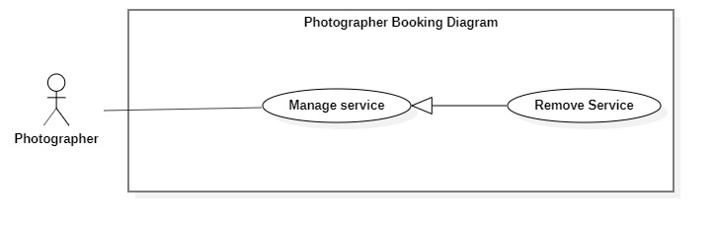***<Photographer> Remove Service***

*Figure 22 - <Photographer> Remove Service*

|  |  |  |  |
| --- | --- | --- | --- |
| UC ID and Name: | **PBS-UC-16 Remove service** | | |
| Created By: | Mytn | Date Created: | 08/10/2020 |
| Primary Actor: | Photographer | Secondary Actors: | Customer |
| Trigger: | The photographer taps remove icon on “Gói dịch vụ”screen. | | |
| Description: | The photographer can remove service. | | |
| Preconditions: | - The photographer has been authenticated.  - The photographer has accessed to the Internet.  - The service pack available. | | |
| Post-conditions: | Success: the photographer remove service successfully.  Fail: System shows error messages. | | |
| Normal Flow: | |  |  |  | | --- | --- | --- | | **Step** | **Actor Action** | **System Response** | | 1 | The photographer taps “Gói dịch vụ” . | The system shows list of services the photographer has view information:  - “Tên gói”: text, required.  - “Nội dung”: text, required  - “Giá”: text, required  - “Thêm dịch vụ”: button  - “Thay đổi”: button | | 2 | The photographer taps remove buttion. | The system shows notifies to the photographer. [Exception 3] | | 3 | The photographer taps “Xác nhận” button | The system sends notifies to the customer. [Exception 1, 2]. | | | |
| Alternative Flows: | N/A | | |
| Exceptions: | |  |  |  | | --- | --- | --- | | **No** | **Actor Action** | **System Response** | | 1 | Network problem | System shows an error message : “Vui lòng kiếm tra lại mạng Internet”. | | 2 | The photographer taps remove icon. | System shows an error message : “Bạn có muốn xóa dịch vụ này?” | | 3 | Remove service successfully | System shows an error message:  “Xóa dịch vụ thành công”. | | | |
| Priority: | High | | |
| Frequency of Use: | N/A | | |
| Business Rules: | Only the photographer can remove service. | | |
| Other Information: | N/A | | |
| Assumptions: | The system allows the photographer can remove service successfully. | | |

1. 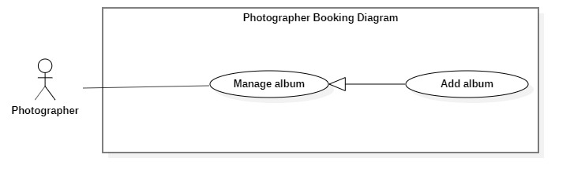***<Photographer>Add album***

*Figure 23 - <Photographer> Add Album*

|  |  |  |  |
| --- | --- | --- | --- |
| UC ID and Name: | **PBS-UC-17 Add Album** | | |
| Created By: | Mytn | Date Created: | 08/10/2020 |
| Primary Actor: | Photographer | Secondary Actors: | Customer |
| Trigger: | The photographer taps add album icon on “Album” screen. | | |
| Description: | The photographer can add album. | | |
| Preconditions: | - The photographer has been authenticated.  - The photographer has accessed to the Internet. | | |
| Post-conditions: | Success: the photographer add album successfully.  Fail: System shows error messages. | | |
| Normal Flow: | |  |  |  | | --- | --- | --- | | **Step** | **Actor Action** | **System Response** | | 1 | The photographer taps “Album” screen and taps add album icon. | The system shows list of album available the photographer has added photo with the following information:  - “Tên album”: input text, required.  - “Hình ảnh”: choose to the device.  - “Thể loại”: input text, required  - “Địa điểm chụp”: input text, required.  - “Thêm album”: button | | 2 | The photographer taps “Thêm album” button | - The system validates inputted data [Exception 1,2].  - The system sends notifies to the customer. [Exception 3]. | | | |
| Alternative Flows: | N/A | | |
| Exceptions: | |  |  |  | | --- | --- | --- | | **No** | **Actor Action** | **System Response** | | 1 | Network problem | System shows an error message : “Vui lòng kiếm tra lại mạng Internet”. | | 2 | “Tên album” and “Hình ảnh”, “thể loại” is empty | System shows an error message : “Thông tin này bắt buộc” | | 3 | Add album successfully | System shows an error message:  “Thêm album thành công”. | | | |
| Priority: | High | | |
| Frequency of Use: | N/A | | |
| Business Rules: | Only the photographer can add album. | | |
| Other Information: | N/A | | |
| Assumptions: | The system allows the photographer can add album successfully. | | |

*Table 20 - <Photographer> Add album use case specification*

1. 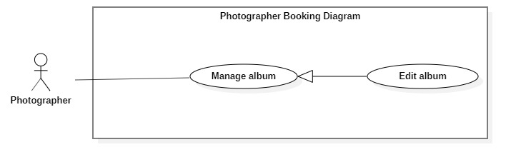***<Photographer> Edit album***

*Figure 24 - <Photographer> Edit Album*

|  |  |  |  |
| --- | --- | --- | --- |
| UC ID and Name: | **PBS-UC-18 Edit Album** | | |
| Created By: | Mytn | Date Created: | 08/10/2020 |
| Primary Actor: | Photographer | Secondary Actors: | Customer |
| Trigger: | The photographer taps “Album” detail and taps “Chỉnh sửa” button. | | |
| Description: | The photographer can edit album. | | |
| Preconditions: | - The photographer has been authenticated.  - The photographer has accessed to the Internet.  - The album available. | | |
| Post-conditions: | Success: the photographer edit album successfully.  Fail: System shows error messages. | | |
| Normal Flow: | |  |  |  | | --- | --- | --- | | **Step** | **Actor Action** | **System Response** | | 1 | The photographer taps “Album”. | The system shows list of photo available. The photographer has view photo with the following information:  - “Tên album”: input text, required.  - “Hình ảnh”: choose to the device.  - “Thể loại”: input text, required  - “Địa điểm chụp”: input text, required.  - “Thêm album”: button  - “Chỉnh sửa”: button | | 2 | The photographer taps “Chỉnh sửa” button. | The system shows detail photo screen. The photographer has edit album with the following information:  - “Tên album”: input text, required.  - “Hình ảnh”: choose to the device.  - “Thể loại”: input text, required  - “Địa điểm chụp”: input text, required.  - “Xác nhận”: button | | 3 | The photographer taps “Xác nhận” button | - The system validates inputted data [Exception 1,2].  - The system sends notifies to the customer. [Exception 3]. | | | |
| Alternative Flows: | N/A | | |
| Exceptions: | |  |  |  | | --- | --- | --- | | **No** | **Actor Action** | **System Response** | | 1 | Network problem | System shows an error message : “Vui lòng kiếm tra lại mạng Internet”. | | 2 | “Tên album” and “Hình ảnh”, “thể loại” is empty | System shows an error message : “Thông tin này bắt buộc” | | 3 | The photographer taps “Xác nhận” button. | System shows an error message:  “Thay đổi album thành công”. | | | |
| Priority: | Medium | | |
| Frequency of Use: | N/A | | |
| Business Rules: | Only the photographer can edit album. | | |
| Other Information: | N/A | | |
| Assumptions: | The system allows the photographer can edit album successfully. | | |

*Table 21 - <Photographer> Edit Album Use Case Specification*

1. 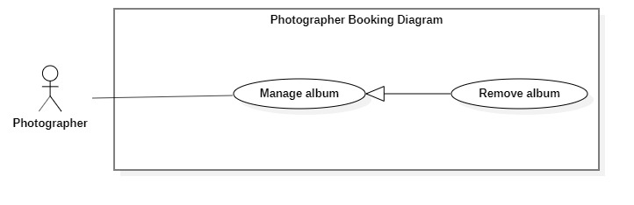***<Photographer> Remove album***

*Figure 25 - <Photographer> Remove Album*

|  |  |  |  |
| --- | --- | --- | --- |
| UC ID and Name: | **PBS-UC-19 Remove Album** | | |
| Created By: | Mytn | Date Created: | 08/10/2020 |
| Primary Actor: | Photographer | Secondary Actors: | Customer |
| Trigger: | The photographer taps remove album button. | | |
| Description: | The photographer can remove album. | | |
| Preconditions: | - The photographer has been authenticated.  - The photographer has accessed to the Internet.  - The album available. | | |
| Post-conditions: | Success: the photographer remove album successfully.  Fail: System shows error messages. | | |
| Normal Flow: | |  |  |  | | --- | --- | --- | | **Step** | **Actor Action** | **System Response** | | 1 | The photographer taps remove album icon. | The system shows notifies to the photographer.[Exception 1, 2] | | 2 | The photographer taps “Xác nhận” button. | The system shows notifies to the photographer. [Exception 3]. | | | |
| Alternative Flows: | N/A | | |
| Exceptions: | |  |  |  | | --- | --- | --- | | **No** | **Actor Action** | **System Response** | | 1 | Network problem | System shows an error message : “Vui lòng kiếm tra lại mạng Internet”. | | 2 | The photographer taps remove album icon. | System shows an error message : “Bnaj có muốn xóa album này?” | | 3 | The photographer taps “Xác nhận” button. | System shows an error message:  “Xóa album thành công”. | | | |
| Priority: | Medium | | |
| Frequency of Use: | N/A | | |
| Business Rules: | Only the photographer can remove album. | | |
| Other Information: | N/A | | |
| Assumptions: | The system allows the photographer can remove album successfully. | | |

#### d. <Authenticated User> Overview Use Case

*Figure 26 - <Authenticated User> Overview Use Case*

1. ***<Authenticated User> Get profile***

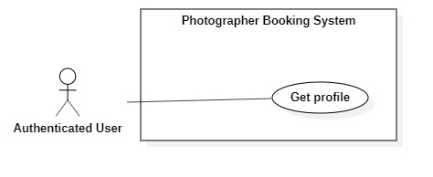

*Figure 27 - <Authenticated User> Get profile*

|  |  |  |  |
| --- | --- | --- | --- |
| UC ID and Name: | **PBS-UC-20 Get profile** | | |
| Created By: | Mytn | Date Created: | 08/10/2020 |
| Primary Actor: | Authenticated User | Secondary Actors: |  |
| Trigger: | The Authenticated User navigates to “Thông tin cá nhân” screen to view profile. | | |
| Description: | The authenticated user can view their profile. | | |
| Preconditions: | The authenticated user has accessed to the Internet. | | |
| Post-conditions: | Success: The Authenticated User can view his/her profile successfully.  Fail: System shows error messages. | | |
| Normal Flow: | |  |  |  | | --- | --- | --- | | **Step** | **Actor Action** | **System Response** | | 1 | The Authenticated User navigates to “Thông tin cá nhân” screen to view profile. | The system shows “Thông tin cá nhân” screen with the following information:  - “Họ và tên”: text input, editable  - “Địa chỉ”: text input, editable  - “Số điện thoại”: phone number input  - “Cập nhật” button: is used to update information.  [Exception 1] | | | |
| Alternative Flows: | N/A | | |
| Exceptions: | |  |  |  | | --- | --- | --- | | **No** | **Actor Action** | **System Response** | | 1 | Network problem | System shows an error message : “Vui lòng kiếm tra lại mạng Internet”. | | | |
| Priority: | Medium | | |
| Frequency of Use: | N/A | | |
| Business Rules: | N/A | | |
| Other Information: | N/A | | |
| Assumptions: | The system allows the authenticated user can view their profile successfully. | | |

*Table 22 - <Authenticated User> Get profile use case specification*

1. ***<Authenticated User> Edit profile***

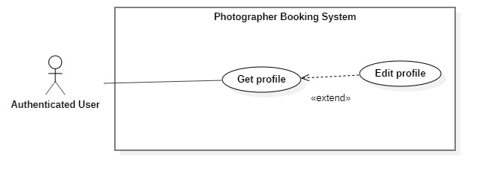

*Figure 28 - <Authenticated User> Edit profile*

|  |  |  |  |
| --- | --- | --- | --- |
| UC ID and Name: | **PBS-UC-21 Edit profile** | | |
| Created By: | Mytn | Date Created: | 08/10/2020 |
| Primary Actor: | Authenticated User | Secondary Actors: |  |
| Trigger: | The Authenticated User taps “Cập nhật” to “Thông tin cá nhân” screen to view profile. | | |
| Description: | The authenticated user can update their profile. | | |
| Preconditions: | The authenticated user has accessed to the Internet. | | |
| Post-conditions: | Success: The Authenticated User can update his/her profile successfully.  Fail: System shows error messages. | | |
| Normal Flow: | |  |  |  | | --- | --- | --- | | **Step** | **Actor Action** | **System Response** | | 1 | The Authenticated User navigates to “Thông tin cá nhân” screen to view profile. | The system shows “Thông tin cá nhân” screen with the following information:  - “Họ và tên”: text input, editable  - “Địa chỉ: text input, editable  - “Số điện thoại”: phone number input.  - “Cập nhật” button: is used to update information.  [Exception 1] | | 2 | The Authenticated User updates information and clicks “Cập nhật” to confirm | The system validates inputted data  [Exception 2] | | 3 |  | The system updates the profile and shows message  [Exception 1, 3] | | | |
| Alternative Flows: | N/A | | |
| Exceptions: | |  |  |  | | --- | --- | --- | | **No** | **Actor Action** | **System Response** | | 1 | Network problem | System shows an error message : “Vui lòng kiếm tra lại mạng Internet”. | | 2 | “Họ và tên”, “địa chỉ”, “Số điện thoại” is empty | System shows an error message : “Thông tin này bắt buộc”. | | 3 | Server has error | System shows an error message: “Lỗi hệ thống. Vui lòng thử lại sau” | | | |
| Priority: | Medium | | |
| Frequency of Use: | N/A | | |
| Business Rules: | N/A | | |
| Other Information: | N/A | | |
| Assumptions: | The system allows the authenticated user can update their profile successfully. | | |

*Table 23 - <Authenticated User> Edit profile use case specification*

1. ***<Authenticated User> Change password***

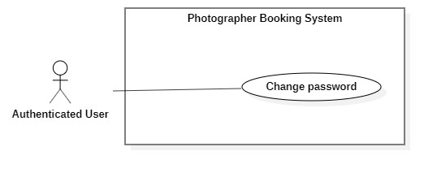

*Figure 29 - <Authenticated User> Change password*

|  |  |  |  |
| --- | --- | --- | --- |
| UC ID and Name: | **PBS-UC-22 Change password** | | |
| Created By: | Mytn | Date Created: | 08/10/2020 |
| Primary Actor: | Authenticated User | Secondary Actors: |  |
| Trigger: | The Authenticated User navigates to “Đổi mật khẩu” screen to change password. | | |
| Description: | The authenticated user can change password. | | |
| Preconditions: | The authenticated user has accessed to the Internet. | | |
| Post-conditions: | Success: The Authenticated User can change password successfully.  Fail: System shows error messages. | | |
| Normal Flow: | |  |  |  | | --- | --- | --- | | **Step** | **Actor Action** | **System Response** | | 1 | The Authenticated User navigates to “Đổi mật khẩu” screen to change password. | The system shows “Đổi mật khẩu” screen with the following inputs:  - “Mật khẩu hiện tại”: current password, password input, required  - “Mật khẩu mới”: new password, password input, required  - “Xác nhận mật khẩu mới”: confirm new password, password input, required  - “Cập nhật” button. | | 2 | The Authenticated User inputs information and taps “Cập nhật” to confirm. | The system validates inputted data  [Exception 2, 4, 5]  The system updates the profile and shows message  [Exception 1, 3] | | | |
| Alternative Flows: | N/A | | |
| Exceptions: | |  |  |  | | --- | --- | --- | | **No** | **Actor Action** | **System Response** | | 1 | Network problem | System shows an error message : “Vui lòng kiếm tra lại mạng Internet”. | | 2 | “Mật khẩu hiện tại”, “Mật khẩu mới”, “xác nhận mật khẩu mới” is empty | System shows an error message : “Thông tin này bắt buộc”. | | 3 | Server has error | System shows an error message: “Lỗi hệ thống. Vui lòng thử lại sau” | | 4 | New password and confirm password do not match. | System shows an error message: “Mật khẩu nhập lại chưa chính xác” | | 5 | Current password is invalid | System shows an error message: “Mật khẩu hiện tại chưa chính xác” | | | |
| Priority: | Medium | | |
| Frequency of Use: | N/A | | |
| Business Rules: | N/A | | |
| Other Information: | N/A | | |
| Assumptions: | The system allows the authenticated user can update password successfully. | | |

Table - <Authenticated User> Change Password Use Case specification

1. 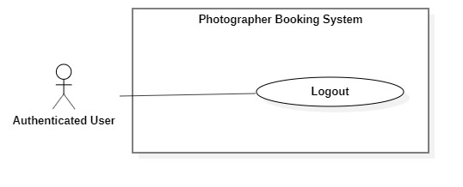***<Authenticated User> Logout***

*Figure 30 - <Authenticated User> Logout*

|  |  |  |  |
| --- | --- | --- | --- |
| UC ID and Name: | **PBS-UC-23 Logout** | | |
| Created By: | Mytn | Date Created: | 08/10/2020 |
| Primary Actor: | Authenticated User | Secondary Actors: |  |
| Trigger: | The Authenticated User navigates to “Cài đặt” screen to log out | | |
| Description: | The system allows the Authenticated User to log out | | |
| Preconditions: | The authenticated user has accessed to the Internet. | | |
| Post-conditions: | Success: The Authenticated User can logout successfully.  Fail: System shows error messages. | | |
| Normal Flow: | |  |  |  | | --- | --- | --- | | **Step** | **Actor Action** | **System Response** | | 1 | The Authenticated User navigates to “Cài đặt” screen to log out | The system deletes login session and navigates the back to “Đăng nhập” screen [Exception 1]. | | | |
| Alternative Flows: | N/A | | |
| Exceptions: | |  |  |  | | --- | --- | --- | | **No** | **Actor Action** | **System Response** | | 1 | Network problem | System shows an error message : “Vui lòng kiếm tra lại mạng Internet”. | | | |
| Priority: | Medium | | |
| Frequency of Use: | N/A | | |
| Business Rules: | N/A | | |
| Other Information: | N/A | | |
| Assumptions: | The system allows the authenticated user can to logout successfully. | | |

*Table 25 - <Authenticated User> Logout use case specification*

#### e. <Admin> Overview Use Case

*Figure 31 - <Admin> Overview Use Case*

1. ***<Admin> Get user’s activity***

*Figure 32 - <Admin> Get user's activity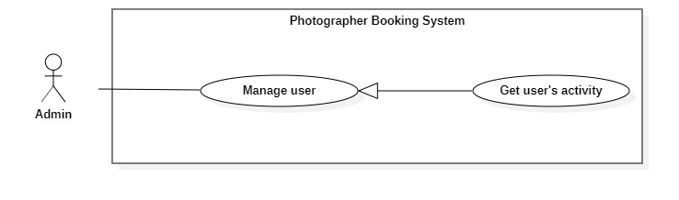*

|  |  |  |  |
| --- | --- | --- | --- |
| UC ID and Name: | **PBS-UC-24 Get user’s activity** | | |
| Created By: | Mytn | Date Created: | 08/10/2020 |
| Primary Actor: | Admin | Secondary Actors: |  |
| Trigger: | The admin taps navigates “Hoạt động” screen. | | |
| Description: | The admin can view a list of user’s activity. | | |
| Preconditions: | - User must be an Admin.  - User has logged into the website. | | |
| Post-conditions: | Success: The admin can view table a list of user’s activity successfully.  Fail: System shows error messages. | | |
| Normal Flow: | |  |  |  | | --- | --- | --- | | **Step** | **Actor Action** | **System Response** | | 1 | The admin taps navigates “Hoạt động” screen. | The system shown table a list of user’s activity. [Exception 1] | | | |
| Alternative Flows: | N/A | | |
| Exceptions: | |  |  |  | | --- | --- | --- | | **No** | **Actor Action** | **System Response** | | 1 | Network problem | System shows an error message : “Vui lòng kiếm tra lại mạng Internet”. | | | |
| Priority: | Medium | | |
| Frequency of Use: | N/A | | |
| Business Rules: | The admin can’t change status user’s activity. | | |
| Other Information: | N/A | | |
| Assumptions: | The system allows the admin can view table a list of user’s activity successfully. | | |

*Table 26 - <Admin> Get use's activity use case specification*

1. 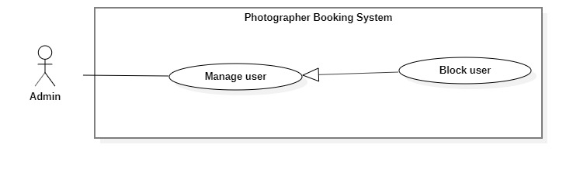***<Admin> Block user***

*Figure 33 - <Admin> Block user*

|  |  |  |  |
| --- | --- | --- | --- |
| UC ID and Name: | **PBS-UC-25 Block user** | | |
| Created By: | Mytn | Date Created: | 08/10/2020 |
| Primary Actor: | Admin | Secondary Actors: |  |
| Trigger: | The admin taps “Khóa” button on the “Danh sách người dùng” screen. | | |
| Description: | The admin can block user if the user violates business role. | | |
| Preconditions: | - User must be an Admin.  - User has logged into the website. | | |
| Post-conditions: | Success: The admin can block user successfully.  Fail: System shows error messages. | | |
| Normal Flow: | |  |  |  | | --- | --- | --- | | **Step** | **Actor Action** | **System Response** | | 1 | The admin taps “Khóa” button on the “Danh sách người dùng” screen. | The system shows notifies to the admin. [Exception 1, 2]. | | 2 | The admin taps “Xác nhận” button. | The system shows notifies to the admin. [Exception 3] | | 3 |  | The system send notifies to the user. [Exception 4]. | | | |
| Alternative Flows: | N/A | | |
| Exceptions: | |  |  |  | | --- | --- | --- | | **No** | **Actor Action** | **System Response** | | 1 | Network problem | System shows an error message : “Vui lòng kiếm tra lại mạng Internet”. | | 2 | The system shows notifies to the admin. | System shows an error message : “Bạn có muốn khóa người dùng này?”. | | 3 | The admin taps “Xác nhận” button. | System shows an error message : “Người dùng đã được khóa thành công”. | | 4 | The system send notifies to the user. | System shows an error messag : “Tài khoản của bạn đã bị vi phạm. Vui lòng liên hệ với quản trị viên”. | | | |
| Priority: | High | | |
| Frequency of Use: | N/A | | |
| Business Rules: | The admin only be lock user when they violates business role. | | |
| Other Information: | N/A | | |
| Assumptions: | The system allows the admin can block user if the user violates business role. | | |

1. 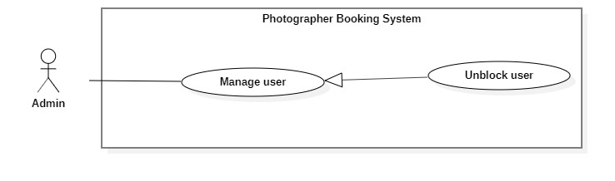***<Admin> Unblock user***

*Figure 34 - <Admin> Unblock user*

|  |  |  |  |
| --- | --- | --- | --- |
| UC ID and Name: | **PBS-UC-26 Unblock user** | | |
| Created By: | Mytn | Date Created: | 08/10/2020 |
| Primary Actor: | Admin | Secondary Actors: |  |
| Trigger: | The admin taps “Mở khóa” button on the “Danh sách người dùng” screen. | | |
| Description: | The admin can unblock user . | | |
| Preconditions: | - User must be an Admin.  - User has logged into the website.  - The user locked. | | |
| Post-conditions: | Success: The admin can unblock user successfully.  Fail: System shows error messages. | | |
| Normal Flow: | |  |  |  | | --- | --- | --- | | **Step** | **Actor Action** | **System Response** | | 1 | The admin taps “Mở khóa” button on the “Danh sách người dùng” screen. | The system shows notifies to the admin. [Exception 1, 2] | | 2 | The admin taps “Xác nhận” button. | The system shows notifies to the admin. [Exception 3] | | | |
| Alternative Flows: | N/A | | |
| Exceptions: | |  |  |  | | --- | --- | --- | | **No** | **Actor Action** | **System Response** | | 1 | Network problem | System shows an error message : “Vui lòng kiếm tra lại mạng Internet”. | | 2 | The system shows notifies to the admin. | System shows an error message : “Bạn có muốn mở khóa người dùng này?”. | | 4 | The admin taps “Xác nhận” button. | System shows an error message : “Người dùng đã được mở khóa thành công”. | | | |
| Priority: | High | | |
| Frequency of Use: | N/A | | |
| Business Rules: | N/A | | |
| Other Information: | N/A | | |
| Assumptions: | The system allows the admin can block user if the user violates business role. | | |

*Table 27 - <Admin> Unblock user use case specification*

1. ***<Admin> Get customer’s review***

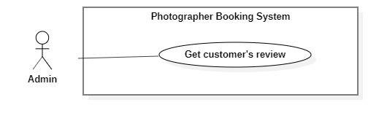

*Figure 35 - <Admin> Get customer's review*

|  |  |  |  |
| --- | --- | --- | --- |
| UC ID and Name: | **PBS-UC-27 Get customer’s review** | | |
| Created By: | Mytn | Date Created: | 08/10/2020 |
| Primary Actor: | Admin | Secondary Actors: | Photographer |
| Trigger: | The admin taps “Trang cá nhân” page of the photographer. | | |
| Description: | The admin can view customer’s review. | | |
| Preconditions: | - User must be an Admin.  - User has logged into the website. | | |
| Post-conditions: | Success: the admin view customer’s review successfully.  Fail: System shows error messages. | | |
| Normal Flow: | |  |  |  | | --- | --- | --- | | **Step** | **Actor Action** | **System Response** | | 1 | The admin taps “Trang cá nhân” page. | - The system shows “Trang cá nhân” page of the photographer. [Exception 1] | | | |
| Alternative Flows: | N/A | | |
| Exceptions: | |  |  |  | | --- | --- | --- | | **No** | **Actor Action** | **System Response** | | 1 | Network problem | System shows an error message : “Vui lòng kiếm tra lại mạng Internet”. | | | |
| Priority: | Medium | | |
| Frequency of Use: | N/A | | |
| Business Rules: | - The admin can’t edit or remove comment of the customer.  -The admin can’t write comment or rating. | | |
| Other Information: | N/A | | |
| Assumptions: | The system allows the admin can view customer’s review. | | |

*Table 28 - <Admin> Get customer's review use case specification*

1. 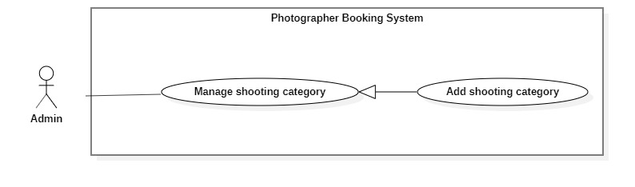***<Admin> Add shooting category***

*Figure 36 - <Admin> Add shooting category*

|  |  |  |  |
| --- | --- | --- | --- |
| UC ID and Name: | **PBS-UC-28 Add shooting category** | | |
| Created By: | Mytn | Date Created: | 08/10/2020 |
| Primary Actor: | Admin | Secondary Actors: |  |
| Trigger: | The admin taps “Thêm thể loại” button. | | |
| Description: | The admin can add shooting category. | | |
| Preconditions: | - User must be an Admin.  - User has logged into the website. | | |
| Post-conditions: | Success: The admin can add shooting successfully.  Fail: System shows error messages. | | |
| Normal Flow: | |  |  |  | | --- | --- | --- | | **Step** | **Actor Action** | **System Response** | | 1 | The admin taps “Thêm thể loại” button. | The system shown “Thêm thể loại chụp ảnh” page. The admin input following:  - “Tên thể loại”: input text, required.  - “Xác nhận” : button. | | 2 | The photographer taps “Xác nhận” button. | - The system validates inputted data  [Exception 1, 2, 3]  - The system shows notifies to the photographer. [Exception 4]. | | | |
| Alternative Flows: | N/A | | |
| Exceptions: | |  |  |  | | --- | --- | --- | | **No** | **Actor Action** | **System Response** | | 1 | Network problem | System shows an error message : “Vui lòng kiếm tra lại mạng Internet”. | | 2 | “Tên thể loại” is empty | System shows an error message : “Thông tin này bắt buộc” | | 3 | “Tên thể loại” is duplicate | System shows an error message : “Thể loại này đã tồn tại” | | 4 | The photographer taps “Xác nhận” button. | System shows an error message:  “Thêm thể loại thành công”. | | | |
| Priority: | Medium | | |
| Frequency of Use: | N/A | | |
| Business Rules: | Only the admin can add shooting category. | | |
| Other Information: | N/A | | |
| Assumptions: | The system allows the admin can add shooting category successfully. | | |

*Table 29 - <Admin> Add shooting category use case specification*

1. ***<Admin> Edit shooting category***

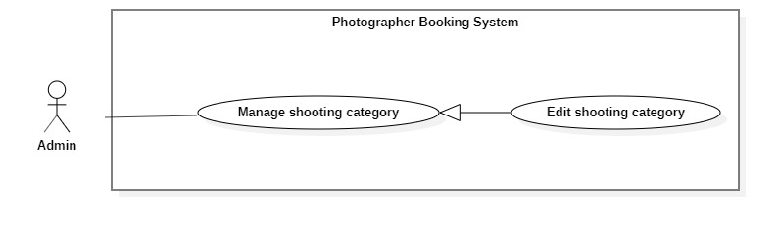

*Figure 37 - <Admin> Edit shooting category*

|  |  |  |  |
| --- | --- | --- | --- |
| UC ID and Name: | **PBS-UC-29 Edit shooting category** | | |
| Created By: | Mytn | Date Created: | 08/10/2020 |
| Primary Actor: | Admin | Secondary Actors: |  |
| Trigger: | The admin taps “Chỉnh sửa” button on the “Thể loại” detail screen. | | |
| Description: | The admin can edit shooting category. | | |
| Preconditions: | - User must be an Admin.  - User has logged into the website.  - The category available. | | |
| Post-conditions: | Success: The admin can edit shooting successfully.  Fail: System shows error messages. | | |
| Normal Flow: | |  |  |  | | --- | --- | --- | | **Step** | **Actor Action** | **System Response** | | 1 | The admin taps “Thể loại” to the view detail . | The system shown a list of category page.  - “Tên thể loại”: text  - “Cập nhật” : button. | | 2 | The photographer taps “Cập nhật” button. | The system shown “Thể loại” detail screen. The admin input following:  - “Tên thể loại”: input text, required.  - “Xác nhận” : button. | | 3 | The photographer taps “Xác nhận” button. | - The system validates inputted data  [Exception 1, 2, 3]  - The system shows notifies to the photographer. [Exception 4]. | | | |
| Alternative Flows: | N/A | | |
| Exceptions: | |  |  |  | | --- | --- | --- | | **No** | **Actor Action** | **System Response** | | 1 | Network problem | System shows an error message : “Vui lòng kiếm tra lại mạng Internet”. | | 2 | “Tên thể loại” is empty | System shows an error message : “Thông tin này bắt buộc” | | 3 | “Tên thể loại” is duplicate | System shows an error message : “Thể loại này đã tồn tại” | | 4 | The photographer taps “Xác nhận” button. | System shows an error message:  “Thay đổi thể loại thành công”. | | | |
| Priority: | Medium | | |
| Frequency of Use: | N/A | | |
| Business Rules: | Only the admin can edit shooting category. | | |
| Other Information: | N/A | | |
| Assumptions: | The system allows the admin can edit shooting category successfully. | | |

*Table 30 - <Admin> Edit shooting category use case specification*

1. ***<Admin> Remove shooting category***

*Figure 38 - <Admin> Remove shooting category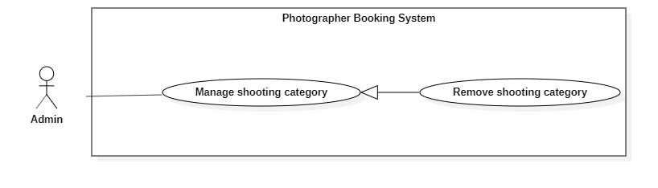*

|  |  |  |  |
| --- | --- | --- | --- |
| UC ID and Name: | **PBS-UC-29 Edit shooting category** | | |
| Created By: | Mytn | Date Created: | 08/10/2020 |
| Primary Actor: | Admin | Secondary Actors: |  |
| Trigger: | The admin taps remove category icon on the “Danh sách thể loại” screen. | | |
| Description: | The admin can remove shooting category. | | |
| Preconditions: | - User must be an Admin.  - User has logged into the website.  - The category available. | | |
| Post-conditions: | Success: The admin can remove shooting successfully.  Fail: System shows error messages. | | |
| Normal Flow: | |  |  |  | | --- | --- | --- | | **Step** | **Actor Action** | **System Response** | | 1 | The admin taps “Thể loại” to the view detail . | The system shown a list of category page. [Exception 1]  - “Tên thể loại”: text  - “Cập nhật” : button. | | 2 | The admin taps remove category icon. | The system shows notifies to the photographer. [Exception 2] | | 3 | The photographer taps “Xác nhận” button. | - The system shows notifies to the photographer. [Exception 3]. | | | |
| Alternative Flows: | N/A | | |
| Exceptions: | |  |  |  | | --- | --- | --- | | **No** | **Actor Action** | **System Response** | | 1 | Network problem | System shows an error message : “Vui lòng kiếm tra lại mạng Internet”. | | 2 | The admin taps remove category icon. | System shows an error message : “bạn có muốn xóa thể loại này ra khỏi thư mục?” | | 3 | The photographer taps “Xác nhận” button. | System shows an error message:  “Xóa thể loại thành công”. | | | |
| Priority: | Medium | | |
| Frequency of Use: | N/A | | |
| Business Rules: | Only the admin can remove shooting category. | | |
| Other Information: | N/A | | |
| Assumptions: | The system allows the admin can remove shooting category successfully. | | |

Table - <Admin> Remove shooting category use case specification

### 2.3 <<Feature name 2 – i.e: Meal Subscriptions>>

#### a. <<Use Case Name 2.1 – i.e Register for Payroll Deduction>>

#### b. <<Next Use Case Name 2.x>>

*[Use Case Description in the same format as above]*

### 2.4 <<Next Feature Name..>>

…

## 3. Functional Requirements

### 3.1 System Functional Overview

#### a. Screen Flow

*[This part show the system screens and the relationship among screens. You can draw the Screens Flow for the system in the form of diagram as below]*

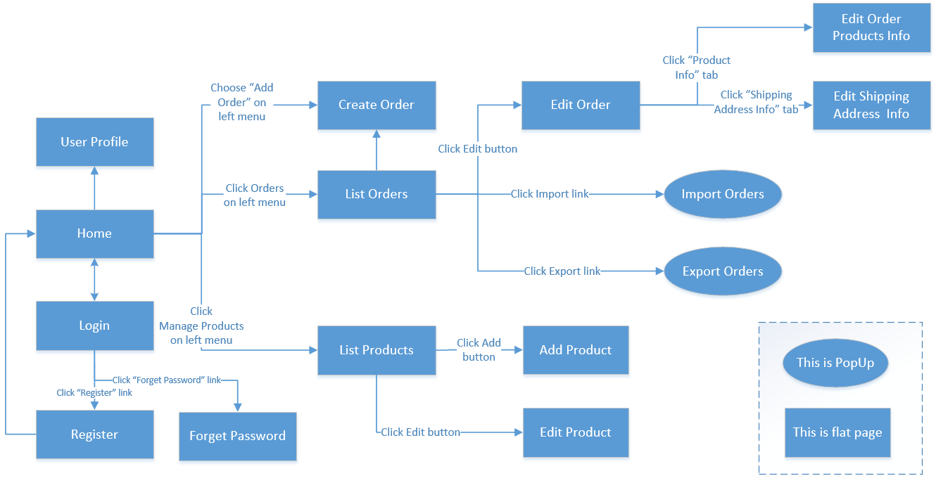

#### b. Screen Details

*[Provide the descriptions for the screens in the Screens Flow above]*

|  |  |  |  |
| --- | --- | --- | --- |
| **#** | **Feature** | **Screen** | **Description** |
| 1 | Order Meals | Create Order | <<Screen Brief description>> |
| 2 | Order Meals | Change Order |  |
| 3 | .. |  |  |

#### c. Screen Authorization

*[Provide the system roles authorization to the system features (down to screens, and event to the screen activities if applicable) in the table form as below – replace Role1, Role2,… with the specific system user role names]*

|  |  |  |  |  |  |
| --- | --- | --- | --- | --- | --- |
| **Screen** | **Role1** | **Role2** | **Role3** | **Role4** | **RoleX** |
| <<Screen Name1>> | X |  |  | X | X |
| <<Screen Activity>> |  |  |  | X | X |
| <<Screen Name2>> | X |  |  | X |  |
| Query All Data | X |  |  |  |  |
| Query Own Data |  |  |  | X |  |
| Query Managed Data |  |  |  | X |  |
| Add New Data |  |  |  | X | X |
| Update All Data |  |  |  |  | X |
| Update Own Data |  |  |  |  | X |
| Update Managed Data |  |  |  |  | X |
| Delete Data |  |  |  |  |  |
| … |  |  |  |  |  |

In which:

* Role1: <<role1 description>>
* Role2: <<role2 description>>
* …

#### d. Non-Screen Functions

*[Provide the descriptions for the non-screen system functions, i.e batch/cron job, service, API, etc.]*

|  |  |  |  |
| --- | --- | --- | --- |
| **#** | **Feature** | **System Function** | **Description** |
| 1 | <<Feature Name>> | <<Function Name1>> | <<Function Name1 Description>> |
| 2 | … |  |  |

#### e. Entity Relationship Diagram

**Entities List**

|  |  |  |
| --- | --- | --- |
| **#** | **Entity** | **Description** |
| 1 | Customer |  |
| 2 | Admins |  |
| 3 | Booking |  |
| 4 | Category |  |
| 5 | Album |  |
| 6 | Photographer |  |
| 7 | Service |  |
| 8 | Review |  |

### 3.2 <<Feature Name 1>>

#### a. <<Function Name 1>>

*[A function can be a screen or a non-screen function (listed in the part 5.1 above). In this part, you need to provide the details on the related function, focus on mentioning below information*

* *Function trigger: how this function is triggered (navigation path, a timing frequency, etc.*
* *Function description: actors/roles, purpose, interface, data processing, etc.*
* *Screen layout: mockup prototype of the screen, sample below is for Manage Products screen*

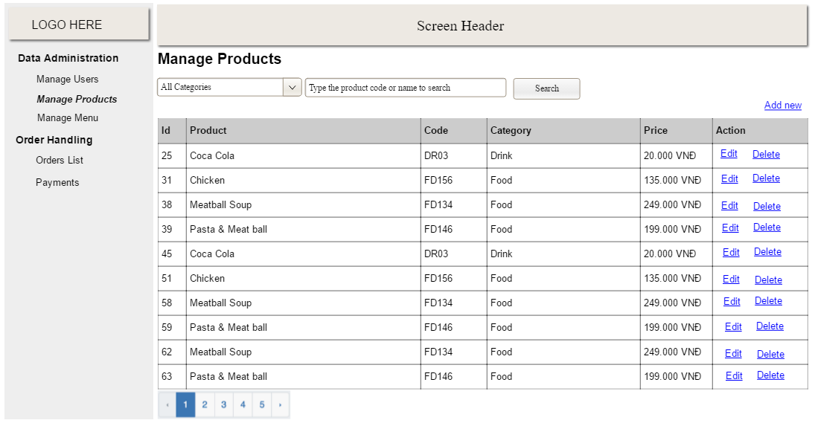

* *Function Details: provide explanation for the data, validation, functionalities (for both normal cases and abnormal cases), etc. of the function so that the reader can image how it work.*

*]*

#### b. <<Function Name 2>>

…

### 3.3 <<Feature Name 2>>

…

## 4. Non-Functional Requirements

### 4.1 External Interfaces

#### a. User Interfaces

*[Describe the logical characteristics of each interface between the software product and the users. This may include sample screen images, any GUI standards or product family style guides that are to be followed, screen layout constraints, standard buttons and functions (e.g., help) that will appear on every screen, keyboard shortcuts, error message display standards, and so on. Define the software components for which a user interface is needed. Details of the user interface design should be documented in a separate user interface specification.]*

UI-1: The Cafeteria Ordering System screen displays shall conform to the Process Impact Internet Application User Interface Standard, Version 2.0 [3].

UI-2: The system shall provide a help link from each displayed webpage to explain how to use that page.

UI-3: The webpages shall permit complete navigation and food item selection by using the keyboard alone, in addition to using mouse and keyboard combinations.

#### b. Software Interfaces

*[Describe the connections between this product and other software components (identified by name and version), including other applications, databases, operating systems, tools, libraries, websites, and integrated commercial components. State the purpose, formats, and contents of the messages, data, and control values exchanged between the software components. Specify the mappings of input and output data between the systems and any translations that need to be made for the data to get from one system to the other. Describe the services needed by or from external software components and the nature of the inte-component communications. Identify data that will be exchanged between or shared across software components. Specify non-functional requirements affecting the interface, such as service levels for responses times and frequencies, or security controls and restrictions.]*

SI-1: Cafeteria Inventory System

SI-1.1: The COS shall transmit the quantities of food items ordered to the Cafeteria Inventory System through a programmatic interface.

SI-1.2: The COS shall poll the Cafeteria Inventory System to determine whether a requested food item is available.

SI-1.3: When the Cafeteria Inventory System notifies the COS that a specific food item is no longer available, the COS shall remove that food item from the menu for the current date.

SI-2: Payroll System

The COS shall communicate with the Payroll System through a programmatic interface for the following operations:

SI-2.1: To allow a Patron to register and unregister for payroll deduction.

SI-2.2: To inquire whether a Patron is registered for payroll deduction.

SI-2.3: To inquire whether a Patron is eligible to register for payroll deduction.

SI-2.4: To submit a payment request for a purchased meal.

SI-2.5: To reverse all or part of a previous charge because a patron rejected a meal or wasn’t satisfied with it, or because the meal was not delivered per the confirmed delivery instructions.

#### c. Hardware Interfaces

*[Describe the characteristics of each interface between the software and hardware (if any) components of the system. This description might include the supported device types, the data and control interactions between the software and the hardware, and the communication protocols to be used. List the inputs and outputs, their formats, their valid values or ranges, and any timing issues developers need to be aware of. If this information is extensive, consider creating a separate interface specification document]*

No hardware interfaces have been identified.

#### d. Communications Interfaces

*[State the requirements for any communication functions the product will use, including e-mail, Web browser, network protocols, and electronic forms. Define any pertinent message formatting. Specify communication security or encryption issues, data transfer rates, handshaking, and synchronization mechanisms. State any constraints around these interfaces, such as whether e-mail attachments are acceptable or not.]*

CI-1: The COS shall send an email or text message (based on user account settings) to the Patron to confirm acceptance of an order, price, and delivery instructions.

CI-2: The COS shall send an email or text message (based on user account settings) to the Patron to report any problems with the meal order or delivery.

### 4.2 Quality Attributes

*[List all the required system characteristics (quality attributes) specification. Some of the possible attributes are provided with the guide/descriptions are mentioned here]*

#### a. Usability

*[This section includes all those requirements that affect usability. For example, specify the required training time for a normal users and a power user to become productive at particular operations specify measurable task times for typical tasks or base the new system’s usability requirements on other systems that the users know and like specify requirement to conform to common usability standards, such as IBM’s CUA standards Microsoft’s GUI standards]*

#### b. Reliability

*[Requirements for reliability of the system should be specified here. Some suggestions follow:*

*Availability—specify the percentage of time available ( xx.xx%), hours of use, maintenance access, degraded mode operations, and so on.*

*Mean Time Between Failures (MTBF) — this is usually specified in hours, but it could also be specified in terms of days, months or years.*

*Mean Time To Repair (MTTR)—how long is the system allowed to be out of operation after it has failed?*

*Accuracy—specifies precision (resolution) and accuracy (by some known standard) that is required in the system’s output.*

*Maximum Bugs or Defect Rate—usually expressed in terms of bugs per thousand lines of code (bugs/KLOC) or bugs per function-point( bugs/function-point).*

*Bugs or Defect Rate—categorized in terms of minor, significant, and critical bugs: the requirement(s) must define what is meant by a “critical” bug; for example, complete loss of data or a complete inability to use certain parts of the system’s functionality.]*

#### c. Performance

*[The system’s performance characteristics are outlined in this section. Include specific response times. Where applicable, reference related Use Cases by name.*

*Response time for a transaction (average, maximum)*

*Throughput, for example, transactions per second*

*Capacity, for example, the number of customers or transactions the system can accommodate*

*Degradation modes (what is the acceptable mode of operation when the system has been degraded in some manner)*

*Resource utilization, such as memory, disk, communications, and so forth.]*

#### d. Dependability

*[Software dependability includes a range of characteristics including reliability, security and safety. Dependable software should not cause physical or economic damage in the event of system failure. Malicious users should not be able to access or damage the system]*

##### d1. Security

*[Specify any requirements regarding security or privacy issues that restrict access to or use of the product. These could refer to physical, data, or software security. Security requirements often originate in business rules, so identify any security or privacy policies or regulations to which the product must conform. If these are documented in a business rules repository, just refer to them.]*

##### d2. Safety

*[Specify requirements that are concerned with possible loss, damage, or harm that could result from use of the product. Define any safeguards or actions that must be taken, as well as potentially dangerous actions that must be prevented. Identify any safety certifications, policies, or regulations to which the product must conform.]*

#### e. Supportability

*[This section indicates any requirements that will enhance the supportability or maintainability of the system being built, including coding standards, naming conventions, class libraries, maintenance access, and maintenance utilities.]*

#### f. Design Constraints

*[This section indicates any design constraints on the system being built. Design constraints represent design decisions that have been mandated and must be adhered to. Examples include software languages, software process requirements, prescribed use of developmental tools, architectural and design constraints, purchased components, class libraries, and so on.]*

#### g. Support Documents

*[Describes the requirements, if any, for o-line user documentation, help systems, help about notices, and so forth.]*

#### h. Purchased Components

*[This section describes any purchased components to be used with the system, any applicable licensing or usage restrictions, and any associated compatibility and interoperability or interface standards.]*

## 5. Other Requirements

### 5.1 Appendix1 - Messages List

|  |  |  |  |  |
| --- | --- | --- | --- | --- |
| **#** | **Message code** | **Message Type** | **Context** | **Content** |
| 1 | MSG01 | In line | There is not any search result | *No search result.* |
| 2 | MSG02 | In red, under the text box | Input-required fields are empty | *The * field is required.* |
| 3 | MSG03 | Toast message | Updating asset(s) information successfully | *Update asset(s) successfully.* |
| 4 | MSG04 | Toast message | Adding new asset successfully | *Add asset successfully.* |
| 5 | MSG05 | Toast message | Confirming email of asset hand-over is sent successfully | *A confirmation email has been sent to {email_address}.* |
| 6 | MSG06 | Toast message | Resetting asset information successfully | *Return asset(s) successfully.* |
| 7 | MSG07 | Toast message | Deleting asset information successfully | *Delete asset(s) successfully.* |
| 8 | MSG08 | In red, under the text box | Input value length > max length | *Exceed max length of {max_length}.* |
| 9 | MSG09 | In line | Username or password is not correct when clicking sign-in | *Incorrrect user name or password. Please check again.* |

### 5.2 Appendix2 - …

### 5.3 …